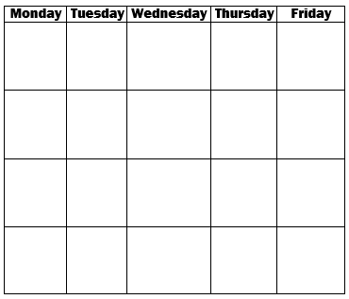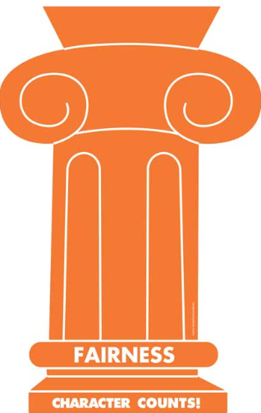h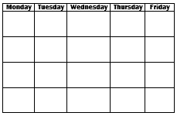

Prefixes:

re

un

dis

We are continuing to use our Spelling and VocabularyWorkbook Unit 21

1. clap
2. step
3. sick
4. rock
5. luck
6. crop
7. snack
8. mess
9. head
10. shut

Academic Awards

28

29

31

Block F Sign Off

Principal’s Pizza Lunch

30

Multicultural

dress up

21

MLK Day

No School

22

GATE @ 7:30 in Tech Lab

Oral Interp.

@ 7:45

SWIM Event

23

24

14

15

Oral Interp.

@ 7:45

Lunch @ 12:35

16

Student Council Meeting

17

School Store Fundraiser Science Fair Meeting

18

Spirit Wear

History & Science Fair Projects due

End of Q2

Unit Skills: Main Idea, Text Structure & Author’s Purpose

Grammar: Similes & Metaphors

Math: Chapter 8: Fractions

Social Studies: Missions

Science: Electricity

Rubrics: [Opinion](https://drive.google.com/file/d/1DFUDLHktTRknCMdnm5cRZvEUZJtfNTEc/view?usp=sharing), [Narrative](https://drive.google.com/file/d/1PrbQiLbUvPvBid-Qvv8XcDtYX7s9Digw/view?usp=sharing), [Informative](https://drive.google.com/file/d/19Bcx8bVltPHlPP-GYyBKFqAuOCqVPPzB/view?usp=sharing) & [Summary](https://drive.google.com/file/d/1i8SsBGUgK2AIr21ujRzjlK5R_jZFkp6A/view?usp=sharing)

25

Spirit Wear

Report Cards go home

AR Points

**A** 90% = 13.5 points

**B** 80% = 12 points

**C** 70% = 10.5 points

**Sparthenian Goal:** 20 points

Math Olympiad @ 7:30

*Wear **RED** on **Wednesday** in January to show caring.*

7

No School

8

GATE @ 7:30 in Tech Lab

Oral Interp.

@ 7:45

9

Student Council Meeting

Science Fair Meeting

10

DI Meeting

@ 7:30

Oral Interp.

@ 7:45

11

Spirit Wear



[Unit 5 Activity Calendar](https://drive.google.com/file/d/0B759YXMfWDSvTlIySV8wcXNvRmc/view?usp=sharing)

[Marlin Messenger](https://fugman.cusd.com/marlinmessenger.aspx)

[Spelling City](https://www.spellingcity.com/users/mrslaceycox)

Week 19 January 14, 2019

January

Reminders

Spelling Words

Our Learning

**4th Grade**

**Classroom News**

Spelling Words

Long a and Short a

Vocabulary