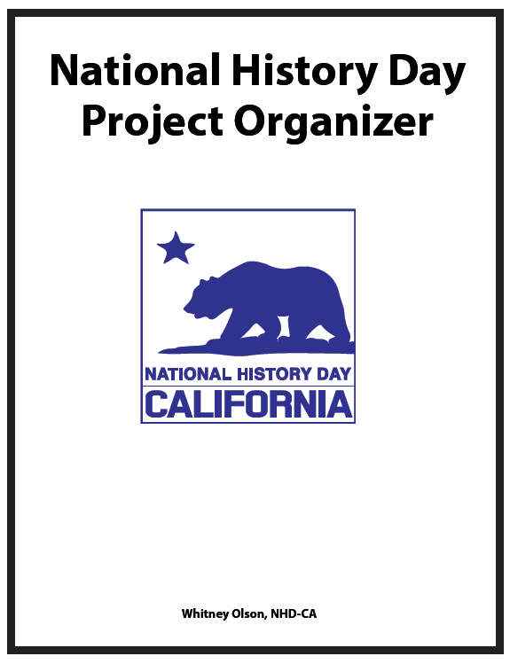

Consider this outline the key to a successful project. Be thorough and the result will be an outline that is very close to a final project. Thoughtful consideration of historical context, turning point/significant event, and historical significance along with the inclusion of multiple perspectives and consideration of historic lenses will result in a well-organized project.

As you work through this organizer, you will want to compile your evidence (research that proves your thesis statement) in threes. For example, you will need three broad historical context categories and within each category you will need at least three examples of your category. Every project category will require depth of research. If you cannot come up with three broad categories that are supported with evidence, you need to do more research!

Directions:
- Paste or write the URL for any online sources.
- Include photos and other graphics.
- Paste or write any quotes.
- Be sure to include bibliographical info on each item you include in the organizer.
- Make sure that all sources used in this organizer are also in your Annotated Bibliography.

Thesis Statement: A one or two sentence statement that summarizes the main point or claim of the project, connects the topic to the theme, and is developed, supported, and explained in the project by means of examples and evidence. An essential element of a thesis statement is an argument or claim.

Historical Context: Historical context refers to the moods, attitudes, and conditions that existed in a certain time. Context is the “setting” for an event that occurs, and it will have an impact on the relevance of the event. Context is an important factor to consider when describing something in history.

Historical Significance: The importance or meaning of history.

Evidence: Evidence is any information, derived from documents, eyewitness accounts, or other primary sources that supports your thesis statement.

Primary Source: A primary source is a document or physical object which was written or created during the time under study. These sources were present during an experience or time period and offer an inside view of a particular event. Examples of primary sources include:
- Diary of Anne Frank - Experiences of a Jewish family during WWII
- The Constitution of Canada - Canadian History
- The image of Martin Luther King Jr. delivering the “I Have a Dream” speech
- The news footage of the fall of the Berlin Wall
- A document from the Library of Congress website

Secondary Source: A secondary source interprets and analyzes primary sources. These sources are one or more steps removed from the event. Secondary sources may have pictures, quotes or graphics of primary sources in them. Examples of secondary sources include:
- A journal/magazine article which interprets or reviews previous findings
- A book written about an event by a reliable author
- A documentary about a historical event or figure
- The National Park Services website summarizing Civil War battles

(Boxes will enlarge as you type.)
What is your topic?

How does it relate to the annual theme?

What is the question you are going to be answering with your project?

(Boxes will enlarge as you type.)
What argument are you presenting with your thesis statement?

What historical significance are you presenting with your thesis statement?

Type your thesis statement into this box. Remember to include the theme words.

All historical research must be placed in context. When thinking about historical context, you should consider:
- What events or conditions created the backdrop for your topic?
- Remember to think about the historical lenses (social, political, economic, religious,
environmental, military, etc.).

Historical context is divided into three sections:
- General history
- Immediately before your topic
- The ideas or philosophy that led to your topic

Each section has a box for you to fill in with evidence and conclusions about the historical context that relates to your topic. In each box include
- A sentence in your own words about how the context relates to your topic
- Three quotes about the conditions/events
- Three or more photos, headlines, charts, maps, or cartoons that illustrate your quotes, and source information for all items.

Your information should answer the following questions:
- What important events happened prior to your topic that are important to understand?
- What circumstances existed before and contributed to your topic? Consider economic changes, political environments, social stability, and cultural growth.
- Who were the people involved in the events that preceded your topic? What role did they play in your topic? How did they become involved?
Be sure to illustrate your conclusions with:
- Quotes
- Headlines
- Photos
- Maps
- Charts
- Political Cartoons

1. In your own words, explain what was happening that set the stage for your topic.

2. Find three or more quotes about the events immediately preceding your topic in your primary or secondary sources.

Citation:

Citation:

Citation:

3. Find three or more relevant images that support your points and connect to your quotes.

Citation: | Citation: | Citation:

1. In your own words, describe the important current events that influenced your topic.
(Boxes will enlarge as you type.)

2. Find three or more quotes about the general historical context in your primary or secondary sources.

Citation:

Citation:

Citation:

3. Find three or more relevant images that support your points and connect to your quotes.
(Drag or copy and paste images here.)
Citation: | Citation: | Citation:

1. In your own words, explain the ideas or philosophical shifts that are important to know in order to understand your topic.

2. Find three or more quotes about these ideas or shifts in your primary or secondary sources.

Citation:

Citation:

Citation:

3. Find three or more relevant images that support your points and connect to your quotes.

Citation: | Citation: | Citation:

At the core of every topic, is a turning point or significant event that you have researched. In this section, you need to clearly show how this turning point/event led to change. You’ve set the stage for this section with your historical context.

Historical significance is divided into three sections:
- Who?
- What?
- How?

Each section has a box for you to fill in with evidence and conclusions about the turning point that relates to your topic. In each box include:
- A sentence in your own words about how the turning point relates to the theme
- Three quotes about the turning point
- Three or more photos, headlines, charts, maps, or cartoons that illustrate your quotes, and source information for all items

Your information should answer the following questions:
- What was the turning point or significant event?
- Who was involved?
- How did these people become involved? How did the turning point/significant event happen?
- What were the immediate results/consequences of this turning point/significant event?

Be sure to illustrate your conclusions with:
- Quotes
- Headlines
- Photos
- Maps
- Charts
- Political Cartoons

1. In your own words, explain the role of key individuals and why they are important to know in order to understand your topic.

2. Find three or more quotes about these people in your primary or secondary sources.

Citation:

Citation:

Citation:

3. Find three or more relevant images that support your points and connect to your quotes.

Citation: | Citation: | Citation:

1. In your own words, explain what changed or the turning point and why this is important to know about your topic.

2. Find three or more quotes that relate to what changed about your topic in your primary or secondary sources.

Citation:

Citation:

Citation:

3. Find three or more relevant images that support your points and connect to your quotes.

Citation: | Citation: | Citation:

1. In your own words, explain how the turning point happened and why this is important to know about your topic.

2. Find three or more quotes in your primary or secondary sources that illustrate how the change or turning point happened.
Citation:

Citation:

Citation:

3. Find three or more relevant images that support your points and connect to your quotes.

Citation: | Citation: | Citation:

Think about historical significance as a row of dominoes. When one domino changes position, it affects the rest of the dominoes. How did the turning point/event create a change or legacy that is significant is history? What long-term changes occurred because of your turning point/event? How were the people/leadership able to accomplish something that has endured?

Remember to think about the historical lenses (social, political, economic, religious, environmental, military, etc.). In each box include a sentence in your own words about how the significance relates to your thesis statement, three quotes about the significance, three or more photos, headlines, charts, maps, or cartoons that illustrate your quotes, and source information for all items.

Historical context is divided into three sections:
- Changed Expectations
- Far Reaching Influence
- Continued Significance

Each section has a box for you to fill in with evidence and conclusions about the
historical significance that relates to your topic. In each box include:
- A sentence in your own words about how the historical significance relates to the theme
- Three quotes about the historical significance
- Three or more photos, headlines, charts, maps, or cartoons that illustrate your quotes, and source information for all items

Your information should answer the following questions:
- What impact did the turning point have on society, the economy, politics.
- In what ways did this turning point influence or change conditions beyond your topic?
- What is the historical significance that can be seen in current or recent events?

Be sure to illustrate your conclusions with:
- Quotes
- Headlines
- Photos
- Maps
- Charts
- Political Cartoons

1. In your own words, explain how the turning point/event changed people’s expectations and why this is significant.

2. Find three or more quotes about changed expectations in your primary or secondary sources.

Citation:

Citation:

Citation:

3. Find three or more relevant images that support your points and connect to your quotes.

Citation: | Citation: | Citation:

1. In your own words, explain the impact of your topic in the larger context of the era.

2. Find three or more quotes about the impact of your topic in your primary or secondary sources.

Citation:

Citation:

Citation:

3. Find three or more relevant images that support your points and connect to your quotes.

Citation: | Citation: | Citation:

1. In your own words, explain what the continued significance of your topic is. Why is it important and how does it continue to matter today?

2. Find three or more quotes about the continued significance in your primary or secondary sources.

Citation:

Citation:

Citation:

3. Find three or more relevant images that support your points and connect to your quotes.

Citation: | Citation: | Citation:

After you have finished your organizer, go back and make sure that the sources you used reflect:
- Multiple Perspectives - have your included all sides of the story?
- Balanced Research - have you used different kinds of sources, both in print and digital?
- Deep Research - do you have both primary and secondary resources?
- Academic Research - are your sources academically credible?

Reread your thesis statement and make sure that:
- It connects to the theme
- You provide evidence that supports or proves the thesis statement
- It contains an argument or point of view that you prove

What are your unanswered questions?
- Ask your teacher/coach/parent to look at your work and tell you what is missing.
- Did you achieve your goal?

Does your project reflect deep analysis?
- Have you used academic language?
- Have you gone beyond retelling?
- Have you considered historical lenses when analyzing your topic (political, social, economic, religious, environmental, military, etc.)?

What is your next step?
- More research?
- Confirming your conclusions with an interview?
- Create a timeline for finishing your project?

You must answer these questions in the text of your process paper. Your paper should have at least 4 paragraphs and be no more than 500 words. Students writing historical papers do not write a process paper.
• First paragraph – how and why did you choose your topic?
• Second paragraph – how did you conduct your research?
• Third paragraph – how did you create your project?
• Fourth paragraph – how does your topic connect to the theme?

Think back to when you chose your topic and write about how and why you chose your topic. Your judges use the process paper as a roadmap for the development of your project.

- How does your topic relate to the theme?
- How did you go about finding information for your topic?
- Where did you find your sources, both digital and in print? Did you visit special locations? Talk with unique sources?
- Highlight the most useful primary sources you found. Why were they useful? What made these sources more helpful than others?
- Highlight the most useful secondary sources you found. Why were they useful? What made these sources more helpful than others?
- What were the hardest aspects of your research? Did you have any unanswered questions?
- What surprised you the most during your research? Did you learn something completely unexpected?
- How does your topic continue to be relevant today?

Your process paper will include all of this information and a description of how you created your project.

Title Page

Create a title page for your process paper and annotated bibliography. Staple all three together. Do not use a cover on any kind. Include only the following information:
- Title of your project
- Your name(s)
- Your division
- Your category
- # of Words in Process Paper
- # of Words on Exhibit, 2-D Display, or Website

After you have finished your organizer, go back and make sure that all of the sources you used
are included in your annotated bibliography. You need to consistently follow one style guide, either MLA or Turabian. Each citation requires a short annotation that addresses the following:

• What type of source is it?
• How did you use the source in your research or the development of your argument?
• If the source is primary, an explanation of why you designated it as primary.
Multiple Perspectives - have your included all sides of the story?

You can also use the annotation to address how the source indicates the strength of your historical inquiry:
• Did the source help you balance your research?
• Did the source provide a different perspective?
• Is the source unique? Explain why.

Divide your sources into primary and secondary sections.

